CAPSTONE PROJECT PROPOSAL
CROP DISEASE CLASSIFICATION USING CONVOLUTIONAL NEURAL NETWORKS (CNNS)
TEAM MEMBERS: JEDIDIAH WAMBUI, PAULINE ONYANGO, DAVE KARANJA
PROGRAM: NGAOLABS DATA SCIENCE TRAINING PROGRAM
DATE: MARCH 23RD, 2026
1. INTRODUCTION
Agriculture plays a critical role in Kenya's economy, contributing approximately 30% of GDP and employing over 40% of the population. A significant proportion of this workforce resides in rural areas and depends on smallholder farming for livelihood.
Despite its importance, the sector is severely constrained by crop diseases, which account for substantial yield losses. According to the Central Bank of Kenya (CBK, 2025), approximately 94% of farmers report pests and diseases as a major factor affecting agricultural production, while 84% cite high input costs and over 80% report transport-related challenges. These constraints reduce productivity and increase vulnerability to food insecurity.
Limited access to agricultural expertise delays disease identification, while traditional manual inspection methods are slow and subjective. Convolutional Neural Networks (CNNs) enable accurate, automated image-based classification, providing a scalable decision support tool for timely intervention and reduced crop losses.
2. PROBLEM STATEMENT
Crop diseases are typically identified too late due to limited access to agronomic expertise and diagnostic tools. This delay results in reduced yields, increased production costs, and food insecurity. There is a need for an automated, accessible, and accurate system that can classify crop diseases using smartphone-captured leaf images, enabling farmers to make informed decisions quickly.
3. OBJECTIVES
3.1 General Objective
To develop a CNN-based multi-class classification system for identifying crop diseases from leaf images.
3.2 Specific Objectives
- To collect and preprocess a labeled dataset of crop leaf images with train/validation/test splits and data augmentation
- To develop and compare a baseline custom CNN and a transfer learning model (MobileNetV2/EfficientNetB0) for multi-class disease classification
- To evaluate model performance using comprehensive classification metrics (accuracy, precision, recall, F1-score, confusion matrix)
- To deploy the best-performing model in a user-accessible Streamlit interface for real-time predictions with confidence scores and advisory messages
4. SCOPE OF THE STUDY
Table
Aspect | Details
Crops | Corn, wheat, and potatoes
Input | Leaf images (smartphone or digital camera)
Output | Disease classification with confidence score and recommendation
Dataset | 13,324 labeled images across 14 classes (sourced from Kaggle: New Plant Diseases Dataset)
Classes | Healthy and diseased leaf categories
Deployment | Streamlit web application
Users | Farmers and agricultural extension officers

Note on Dataset: The dataset contains disease categories only. While pests are mentioned in agricultural literature as a related problem, this project focuses specifically on disease classification due to data availability.
5. METHODOLOGY
5.1 Data Collection
Source: New Plant Diseases Dataset (Ahmed, 2019)
Dataset Characteristics:
- Total images: 13,324
- Format: RGB images, various original sizes
- Classes: 14 categories representing healthy and diseased states of corn, potato, and wheat
Class Distribution:
Table
Class Name | Description | Crop | Status
Corn_(maize)_Cercospora_leaf_spot Gray_leaf_spot | Fungal disease | Corn | Diseased
Corn_(maize)Common_rust | Fungal disease | Corn | Diseased
Corn_(maize)_Northern_Leaf_Blight | Fungal disease | Corn | Diseased
Corn_(maize)_healthy | Healthy state | Corn | Healthy
Potato_Early_blight | Fungal disease | Potato | Diseased
Potato_Late_blight | Oomycete disease | Potato | Diseased
Potato_healthy | Healthy state | Potato | Healthy
Wheat_Healthy | Healthy state | Wheat | Healthy
Wheat_septoria | Fungal disease | Wheat | Diseased
Wheat_stripe_rust | Fungal disease | Wheat | Diseased
Note: Exact image counts per class will be documented during EDA phase.
5.2 Data Preprocessing
Table
Step | Description
Image Resizing | Standardize to 224 × 224 pixels (compatible with pre-trained models)
Pixel Normalization | Scale to [0, 1] range
Data Splitting | Stratified train/validation/test split (70/15/15)
Stratification | Preserve class proportions across splits to handle any imbalance
Data Augmentation (Training Set) | Random rotation (±20°), horizontal flip, zoom (±20%), brightness adjustment
5.3 Exploratory Data Analysis (EDA)
- Class distribution visualization (bar charts, pie charts)
- Sample image inspection per class (grid display)
- Image size and quality consistency check
- Duplicate detection and removal
- Class balance assessment (identify minority/majority classes)
5.4 Model Development
Approach: Comparative modeling with two architectures
Table
Model | Architecture | Rationale
Model A (Baseline) | Custom CNN | Establish performance floor, demonstrate fundamental CNN understanding
Model B (Transfer Learning) | MobileNetV2 or EfficientNetB0 | Leverage pre-trained ImageNet weights for improved accuracy and faster convergence
Custom CNN Architecture (Tentative):
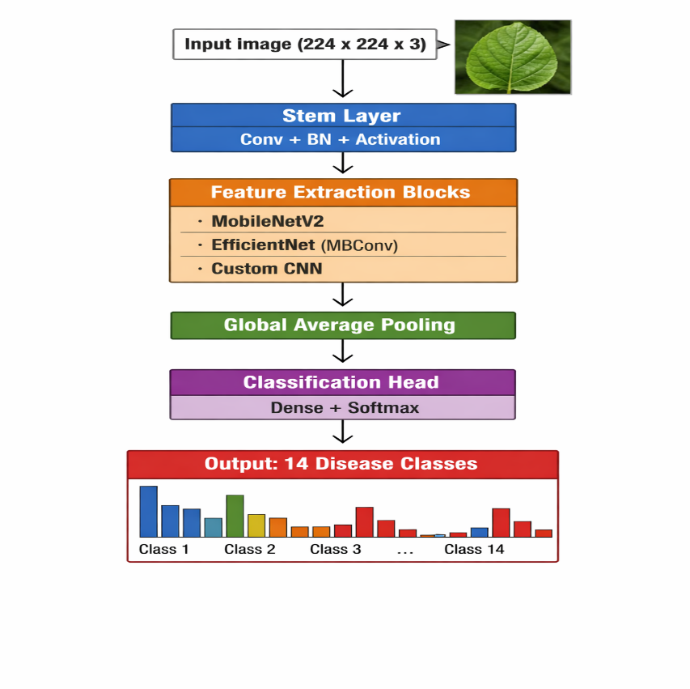
Transfer Learning Setup:
- Base: MobileNetV2 (lightweight, mobile-optimized) or EfficientNetB0 (better accuracy-efficiency trade-off)
- Pre-trained weights: ImageNet
- Fine-tuning strategy: Freeze base layers initially, then unfreeze top layers for fine-tuning
Training Configuration:
- Optimizer: Adam (learning rate: 0.001, adjustable)
- Loss: Categorical Crossentropy
- Batch size: 32 (adjustable based on memory)
- Epochs: 20-50 with early stopping (patience: 5)
- Callbacks: ModelCheckpoint (save best), ReduceLROnPlateau, EarlyStopping
5.5 Model Evaluation
Metrics (comprehensive):
- Accuracy: Overall correct predictions
- Precision: Per-class and macro-average (minimize false positives)
- Recall: Per-class and macro-average (minimize false negatives)
- F1-Score: Per-class, macro, and weighted (primary metric for imbalanced data)
- Confusion Matrix: Visualize misclassification patterns
- Classification Report: Per-class precision, recall, F1
Model Selection Criteria:
- Highest weighted F1-score (accounts for class imbalance)
- Inference speed (deployment efficiency)
- Model size (for deployment constraints)
Validation Strategy:
- Hold-out test set evaluation
- Cross-validation if dataset size permits

6. DEPLOYMENT PLAN
Platform: Streamlit (Python-based, rapid development, ideal for ML demos)
Application Features:
- Image Upload: Drag-and-drop or file selector for leaf images
- Prediction Display:
  - Predicted disease class
  - Confidence score (softmax probability)
  - Top-3 predictions with probabilities (optional)
- Advisory Message: Rule-based recommendation based on predicted class (e.g., "Apply fungicide X," "Consult extension officer," "Crop appears healthy")
- Visualization: Grad-CAM or similar attention visualization (if time permits)

Conceptual Framework: From Image Capture to Diagnosis
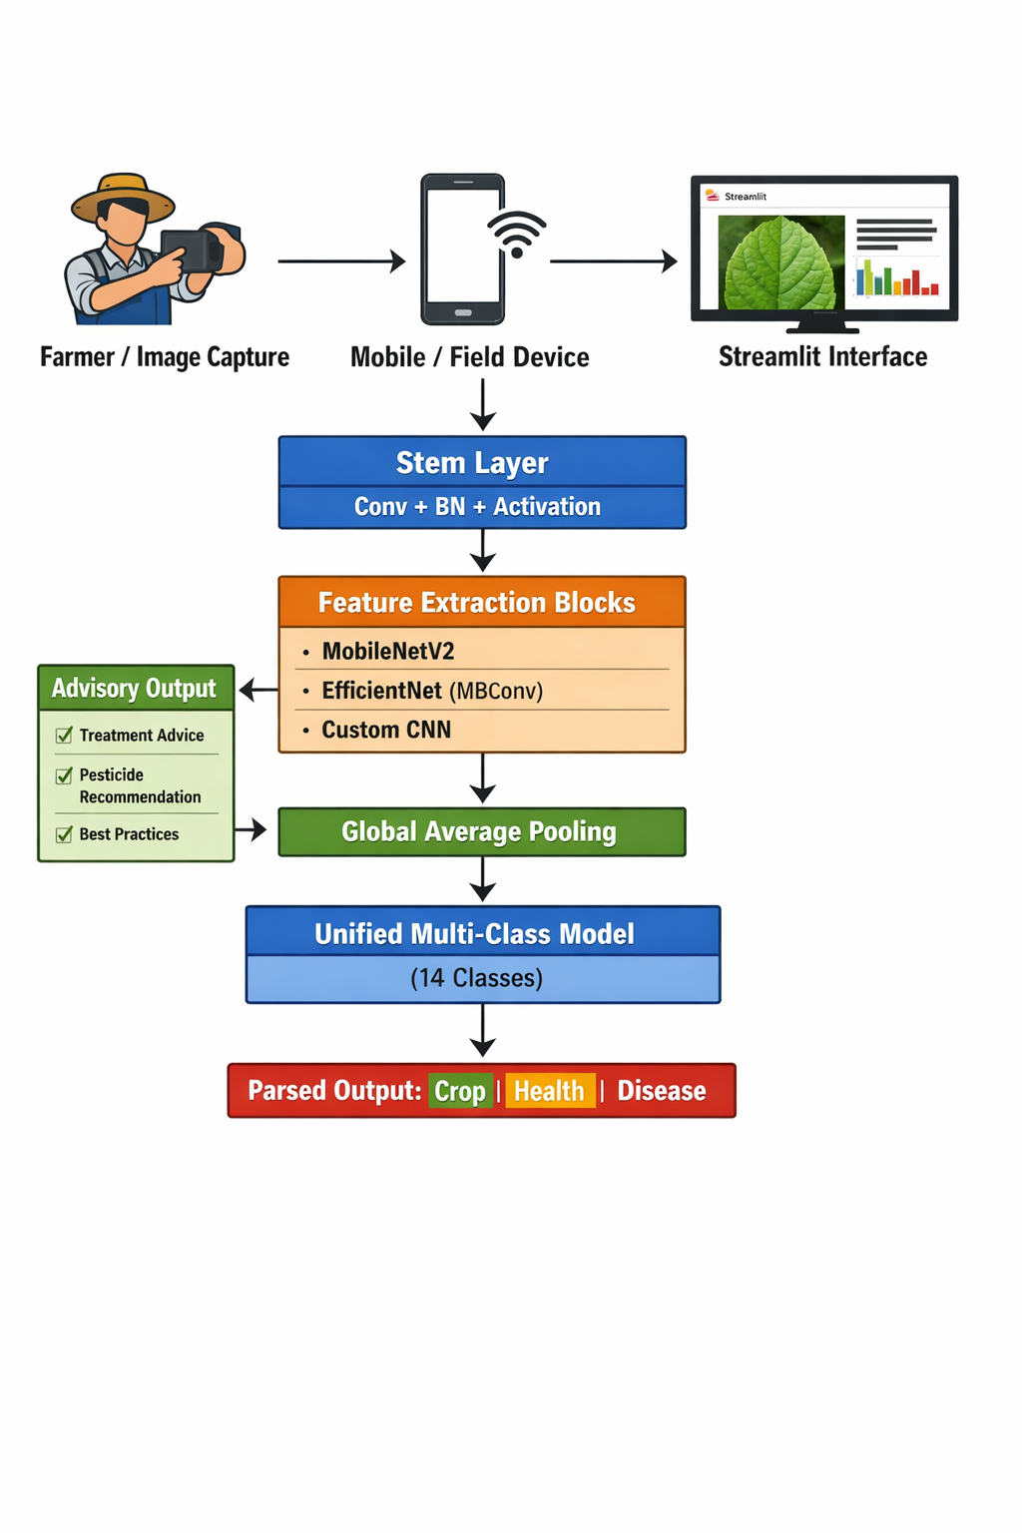
Technical Stack:
- Frontend/Backend: Streamlit
- Model serving: Load Keras/TensorFlow model
- Hosting: Streamlit Cloud (free tier) or local deployment
7. EXPECTED OUTCOMES
- A trained CNN model capable of accurately classifying 14 crop disease categories
- Comparative analysis showing transfer learning vs. custom CNN performance
- A functional Streamlit application for real-time disease diagnosis
- Improved accessibility of diagnostic tools for farmers
- Foundation for future expansion to additional crops and disease types
8. SIGNIFICANCE OF THE STUDY
- Enhances agricultural productivity through rapid disease identification
- Reduces dependency on scarce agricultural experts for initial diagnosis
- Provides a scalable, cost-effective decision support solution
- Supports food security initiatives by enabling timely intervention
- Demonstrates practical application of deep learning in developing economy contexts

9. WORK PLAN
Table
Phase | Activity | Duration | Deliverable
1 | Dataset verification & EDA | 3 days | EDA notebook with class analysis, sample visualizations
2 | Data preprocessing pipeline | 2 days | Preprocessed datasets, augmentation pipeline
3 | Baseline custom CNN development | 3 days | Trained baseline model, initial metrics
4 | Transfer learning model development | 3 days | Trained MobileNetV2/EfficientNet model
5 | Model comparison & selection | 2 days | Comparative report, selected final model
6 | Streamlit application development | 3 days | Functional deployed application
7 | Testing, documentation & reporting | 2 days | Final report, presentation, GitHub repository
Total Duration: ~2.5-3 weeks

10. BUDGET
Table
Item | Resource | Cost
Computing | Google Colab (free tier) or local GPU | Free
Dataset | Kaggle download | Free
Development | Python, TensorFlow/Keras, Streamlit | Free
Deployment | Streamlit Cloud or local server | Free
Total |  | Zero cost

LIMITATIONS & FUTURE WORK
Current Limitations:
- Dataset images are lab-controlled with uniform backgrounds; real-world field images may vary in lighting, angle, and background clutter
- Classification is limited to diseases only; pest detection not included due to data unavailability
- System provides decision support but does not replace professional agricultural expertise
- Model performance depends on image quality (resolution, focus, lighting)
Future Enhancements:
- Collect and incorporate real field images for robustness
- Expand to additional crops (tomato, beans, rice)
- Integrate pest detection with appropriate datasets
- Add treatment recommendation database
- Develop mobile app for offline usage
- Implement active learning for continuous model improvement

CONCLUSION
This project proposes a CNN-based crop disease classification system using image recognition. By consolidating the approach into a single robust multi-class classifier and comparing custom and transfer learning architectures, the project delivers a technically sound, deployable solution. The Streamlit-based deployment ensures accessibility for Kenyan farmers and extension officers, contributing to improved agricultural decision-making and food security.

REFERENCES
- Central Bank of Kenya. (2025). Agricultural Sector Survey Report.
- Ahmed, M. (2019). New Plant Diseases Dataset. Kaggle. https://www.kaggle.com/datasets/vipoooool/new-plant-diseases-dataset
- Howard, A. G., et al. (2017). MobileNets: Efficient Convolutional Neural Networks for Mobile Vision Applications. arXiv preprint arXiv:1704.04861.
- Tan, M., & Le, Q. (2019). EfficientNet: Rethinking Model Scaling for Convolutional Neural Networks. ICML 2019.

